IW-12
YEAR 8 SCIENCE (MODIFIED)
GEOLOGY TEST

NAME: CLASS:

Mark: 
Mark | ND | NW | C | HC | O
Mark Range | 0 - 10 | 11 - 18 | 19 - 25 | 26 - 33 | 34 - 43

QUESTION | ANSWER
1
2
3
4
5
6
7
8
9
10
11
12
13
14
15
16
17
18
1. Sometimes the roots of a tree will split open a large rock. This
is an example of:

(a) physical weathering.
(b) chemical weathering.
(c) erosion.
(d) sedimentation.

2. Sometimes in central Australia, there are huge dust storms that
block out the Sun. They are caused by strong winds. This is a
very good example of:

(a) chemical weathering.
(b) sedimentation.
(c) physical weathering.
(d) erosion.

3. Granite is an igneous rock because it:

(a) is formed underground.
(b) is formed when molten rock cools down and forms a solid rock.
(c) is very hard and will scratch most metals.
(d) does not usually contain fossils.

4. What is meant by the term ‘magma’?

(a) Magma is a rock that has solidified from molten rock.
(b) Magma is molten rock that has flowed out onto the Earth’s
surface.
(c) Magma is molten rock under the surface of the Earth.
(d) Magma is an igneous rock such as granite.

5. Which of the following statements about rocks is correct?

(a) Sedimentary rocks are usually harder than igneous rocks.
(b) Metamorphic rocks have been formed from other rocks by the
effects of heat and pressure.
(c) Igneous rocks may contain fossils.
(d) Igneous rocks may have layers of crystals cemented together.

Use the labels on the diagram of an active volcano given below to answer the next two questions.

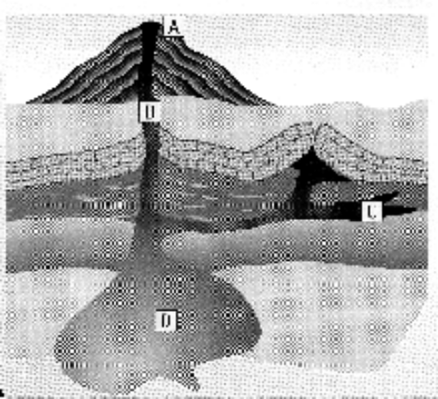

6. Where would you find extrusive rocks that cool quickly?

(a) A
(b) B
(c) C
(d) D

7. Where would the temperature be highest?

(a) A
(b) B
(c) C
(d) D

8. A metamorphic rock, produced by applying heat and pressure, is _____ than the original material.

(a) more bendable
(b) stronger
(c) softer
(d) lighter

9. What evidence would indicate that a rock sample had solidified and cooled very slowly inside the
Earth?

(a) Dark colour.
(b) Very hard.
(c) Large crystals.
(d) Small crystals.

10. Which of the following could cause chemical weathering to happen?

(a) Running water.
(b) Heating and cooling.
(c) Wind.
(d) Acid rain.

11. Which of the following is not going to cause erosion?

(a) Wind.
(b) Gravity.
(c) Water.
(d) Acid rain.

12. Which of the following statements is correct?

(a) There are two main types of rocks: igneous and sedimentary.
(b) Lava refers to molten rock when it is beneath the Earth's surface.
Mineral | Streak | Hardness | Lustre | Colour
Diamond | No streak | 10 | Glassy | Colourless
Quartz | White | 7 | Glassy | White
Calcite | White | 3 | Glassy | White
Talc | White | 1 | Glassy | White
(c) Magma refers to the molten rock that has flowed out onto the Earth's surface.
(d) Physical properties used to identify minerals are colour, hardness, lustre and streak colour.

The following table can be used to answer questions 13 - 15.

13. Which is the hardest mineral?

(a) diamond
(b) quartz
(c) calcite
(d) talc

14. Another name for the ‘shininess’ of a mineral is:

(a) streak.
(b) transparency.
(c) crystal.
(d) lustre.

15. Why does diamond produce no streak but the other minerals do?

(a) The diamond is too hard, it does not leave a mark on the porcelain tile.
(b) The diamond is too soft, it crumbles instead of leaving a mark.
(c) The diamond is colourless.
(d) It does leave a streak, but only on other minerals.

16. When minerals form a definite shape and their surfaces have faces we say the mineral has formed:

(a) An element.
(b) A compound.
(c) A crystal.
(d) A cleavage.

17. Rocks that have been formed from other rocks due to intense heat and pressure are called:

A sedimentary.
B igneous.
C metamorphic.
D mineralised.

18. The primary difference between magma and lava is that:

A magma becomes lava anytime it is in a cooling condition.
B they are produced from different parent materials.
C one is below the ground; the other is above the ground.
D one contains more iron and oxygen than the other.

Short Answer Write the answer to the questions in the spaces provided.

1. In the table below, choose the correct meaning for each word given. Write the letter of the correct
meaning next to the word.

WORD | CORRECT  LETTER | MEANINGS
streak |  | A - rock formed inside the ground.
hardness |  | B - describes the shininess of a mineral when light strikes it.
intrusive |  | C - rock formed by sediment settling at the bottom of a lake.
lustre |  | D - powdery mark left when scratched on a tile.
extrusive |  | E - pure, naturally-occurring materials that make up rocks.
sedimentary |  | F - a smooth plane that a mineral breaks along.
cleavage |  | G - determined by scratching one mineral against another.
mineral |  | H - rock formed on the surface of the ground.

(8)
2. The table to the right is called the Moh Scale.
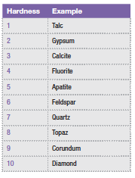
(a) List 2 substances that can be scratched by feldspar.

•

• (2)

(b) Diamond is very hard. Which substance in the table can be
used to cut or scratch diamond?

• (1)

3. In the laboratory, you did an experiment to determine the relationship between the rate of cooling of a
molten substance and the size of the crystals that are formed.

(a) What is the variable you change (independent variable)?

• (1)

(b) Which variable would you measure?

•
(1)

(c) Under which conditions will large crystals form - fast or slow cooling?

• (1)

(d) Will large crystals in rocks form on top of the ground or below the ground? Explain your
answer.

(2)

4. Explain how each of the following types of rock are formed. You might like to draw simple diagrams
to help your explanation.

(a) Igneous rock.

(b) Sedimentary rock.

(c) Metamorphic rock.

(3)
5. (a) Explain what the difference is between weathering and erosion.

Weathering:

Erosion:

(2)
(b) A river can carve out a valley through hills and mountains as it flows down to the lowest level.
The Colorado River has formed the Grand Canyon in the United States, which is up to 1800 m
deep. The rock in the area is sedimentary - layered and relatively soft., made mainly of
sandstone.

(i) Why can it carve through the rock?

(1)

(ii) What does it carry with it as it flows?

(1)

(iii) Large rocks in the river are smooth. Explain how this happens.

(2)

